
Full Stack Development
Lab 2-2-2026

Name:Aditya K U
Roll:AV.SC.U4AIE23001
AIE-A

Bootstrap
1. Write a program to create a simple responsive webpage with a header, main
content area, and a footer using Bootstrap’s grid system, containers,
and typography classes.

HTML Code
l<!DOCTYPE html>
<html lang="en">
<head>
<meta charset="UTF-8">
<meta name="viewport" content="width=device-width, initial-scale=1.0">

<title>Simple Bootstrap Webpage</title>

<link href="https://cdn.jsdelivr.net/npm/bootstrap@5.3.2/dist/css/bootstrap.min.css" rel="stylesheet">
</head>

<body>

<header class="bg-primary text-white text-center py-4">
<div class="container">
<h1 class="display-5">My Bootstrap Webpage</h1>
<p class="lead">A simple responsive layout using Bootstrap</p>
</div>
</header>

<main class="container my-5">

<div class="row">

<div class="col-md-8">
<h2 class="mb-3">Main Content</h2>

<p class="text-muted">
This is the main content area of the webpage. Bootstrap's grid system
makes it easy to create responsive layouts that adjust to different
screen sizes automatically.
</p>

<p>
The layout uses Bootstrap containers, rows, and columns to organize
the content. On smaller screens, the columns will stack vertically.
</p>
</div>

<div class="col-md-4">
<h3>Sidebar</h3>

<ul class="list-group">
<li class="list-group-item">Item 1</li>
<li class="list-group-item">Item 2</li>
<li class="list-group-item">Item 3</li>
</ul>
</div>

</div>

</main>

<footer class="bg-dark text-white text-center py-3">
<div class="container">
<p class="mb-0">© 2026 My Website | Built with Bootstrap</p>
</div>
</footer>

<script src="https://cdn.jsdelivr.net/npm/bootstrap@5.3.2/dist/js/bootstrap.bundle.min.js"></script>

</body>
</html>
Output:
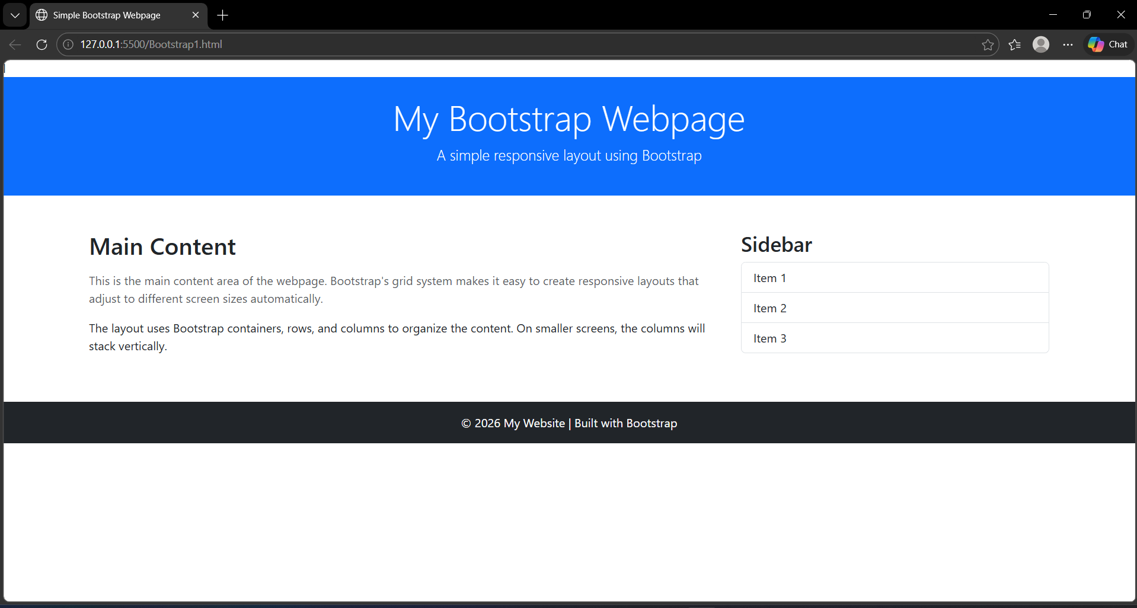

2. Write a program to build a responsive product gallery using Bootstrap’s cards
and buttons, where each card displays an image, title, description, and
a call-to-action button.
HTML Code
<!DOCTYPE html>
<html lang="en">
<head>
<meta charset="UTF-8">
<meta name="viewport" content="width=device-width, initial-scale=1.0">

<title>Car Product Gallery</title>

<link href="https://cdn.jsdelivr.net/npm/bootstrap@5.3.2/dist/css/bootstrap.min.css" rel="stylesheet">

</head>

<body>

<div class="container my-5">

<h1 class="text-center mb-4">Car Product Gallery</h1>

<div class="row g-4">

<div class="col-md-4 col-sm-6">
<div class="card h-100">
<img src="1.jpg" class="card-img-top" alt="Tesla Model S">
<div class="card-body">
<h5 class="card-title">Tesla Model S</h5>
<p class="card-text">
A premium electric sedan known for its incredible acceleration, long range battery, and advanced autopilot technology.
</p>
<a href="#" class="btn btn-primary">View Details</a>
</div>
</div>
</div>

<div class="col-md-4 col-sm-6">
<div class="card h-100">
<img src="2.jpg" class="card-img-top" alt="BMW M4">
<div class="card-body">
<h5 class="card-title">BMW M4</h5>
<p class="card-text">
A high-performance sports coupe with aggressive styling, powerful turbocharged engine, and exceptional driving dynamics.
</p>
<a href="#" class="btn btn-primary">View Details</a>
</div>
</div>
</div>

<div class="col-md-4 col-sm-6">
<div class="card h-100">
<img src="3.jpg" class="card-img-top" alt="Audi R8">
<div class="card-body">
<h5 class="card-title">Audi R8</h5>
<p class="card-text">
A luxurious supercar featuring a V10 engine, sleek design, and cutting-edge technology for ultimate performance.
</p>
<a href="#" class="btn btn-primary">View Details</a>
</div>
</div>
</div>

<div class="col-md-4 col-sm-6">
<div class="card h-100">
<img src="4.jpg" class="card-img-top" alt="Ford Mustang">
<div class="card-body">
<h5 class="card-title">Ford Mustang</h5>
<p class="card-text">
An iconic American muscle car known for its bold design, powerful engine options, and thrilling driving experience.
</p>
<a href="#" class="btn btn-primary">View Details</a>
</div>
</div>
</div>

<div class="col-md-4 col-sm-6">
<div class="card h-100">
<img src="5.jpg" class="card-img-top" alt="Lamborghini Huracan">
<div class="card-body">
<h5 class="card-title">Lamborghini Huracan</h5>
<p class="card-text">
A stunning Italian supercar offering extreme speed, aerodynamic design, and a roaring V10 engine.
</p>
<a href="#" class="btn btn-primary">View Details</a>
</div>
</div>
</div>

<div class="col-md-4 col-sm-6">
<div class="card h-100">
<img src="6.jpg" class="card-img-top" alt="Mercedes Benz C-Class">
<div class="card-body">
<h5 class="card-title">Mercedes-Benz C-Class</h5>
<p class="card-text">
A luxury sedan combining elegant design, advanced safety features, and a comfortable driving experience.
</p>
<a href="#" class="btn btn-primary">View Details</a>
</div>
</div>
</div>

<div class="col-md-4 col-sm-6">
<div class="card h-100">
<img src="7.jpg" class="card-img-top" alt="Toyota Supra">
<div class="card-body">
<h5 class="card-title">Toyota Supra</h5>
<p class="card-text">
A legendary sports car featuring a turbocharged engine, aerodynamic design, and outstanding handling.
</p>
<a href="#" class="btn btn-primary">View Details</a>
</div>
</div>
</div>

<div class="col-md-4 col-sm-6">
<div class="card h-100">
<img src="8.jpg" class="card-img-top" alt="Porsche 911">
<div class="card-body">
<h5 class="card-title">Porsche 911</h5>
<p class="card-text">
A timeless sports car with precise engineering, powerful performance, and unmatched driving pleasure.
</p>
<a href="#" class="btn btn-primary">View Details</a>
</div>
</div>
</div>

<div class="col-md-4 col-sm-6">
<div class="card h-100">
<img src="9.jpg" class="card-img-top" alt="Ferrari F8">
<div class="card-body">
<h5 class="card-title">Ferrari F8</h5>
<p class="card-text">
A high-performance Italian supercar delivering breathtaking speed, luxury, and advanced aerodynamics.
</p>
<a href="#" class="btn btn-primary">View Details</a>
</div>
</div>
</div>

<div class="col-md-4 col-sm-6">
<div class="card h-100">
<img src="10.jpg" class="card-img-top" alt="Range Rover Sport">
<div class="card-body">
<h5 class="card-title">Range Rover Sport</h5>
<p class="card-text">
A premium SUV known for its off-road capability, luxurious interior, and powerful engine options.
</p>
<a href="#" class="btn btn-primary">View Details</a>
</div>
</div>
</div>

</div>
</div>

<script src="https://cdn.jsdelivr.net/npm/bootstrap@5.3.2/dist/js/bootstrap.bundle.min.js"></script>

</body>
</html>

Output:
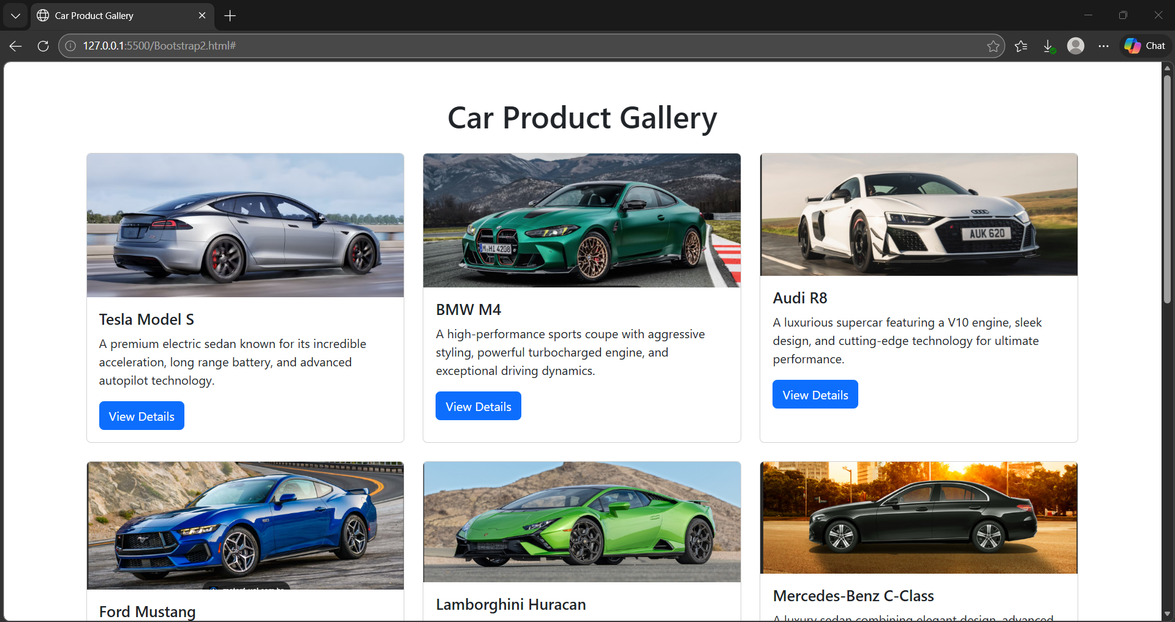
3. Write a program to design a contact form with different input types
(text, email, textarea) and use Bootstrap’s form-control and
input-group classes to style and organize the form fields.
HTML Code
<!DOCTYPE html>
<html lang="en">
<head>
<meta charset="UTF-8">
<meta name="viewport" content="width=device-width, initial-scale=1.0">

<title>Bootstrap Contact Form</title>

<link href="https://cdn.jsdelivr.net/npm/bootstrap@5.3.2/dist/css/bootstrap.min.css" rel="stylesheet">

</head>
<body>
<div class="container">
<div class="form-container">
<h2 class="text-center mb-4">Contact Us</h2>
<form>
<div class="mb-3">
<label class="form-label">Full Name</label>
<input type="text" class="form-control" placeholder="Enter your name">
</div>

<div class="mb-3">
<label class="form-label">Email Address</label>
<input type="email" class="form-control" placeholder="Enter your email">
</div>

<div class="mb-3">
<label class="form-label">Phone Number</label>

<div class="input-group">
<span class="input-group-text">+91</span>
<input type="text" class="form-control" placeholder="Enter phone number">
</div>

</div>
<div class="mb-3">
<label class="form-label">Subject</label>
<input type="text" class="form-control" placeholder="Enter subject">
</div>
<div class="mb-3">
<label class="form-label">Message</label>
<textarea class="form-control" rows="4" placeholder="Write your message here"></textarea>
</div>
<div class="d-grid gap-2">

<button type="submit" class="btn btn-primary">
Send Message
</button>

<button type="reset" class="btn btn-secondary">
Reset Form
</button>
</div>
</form>
</div>
</div>
<script src="https://cdn.jsdelivr.net/npm/bootstrap@5.3.2/dist/js/bootstrap.bundle.min.js"></script>
</body>
</html>

Output:
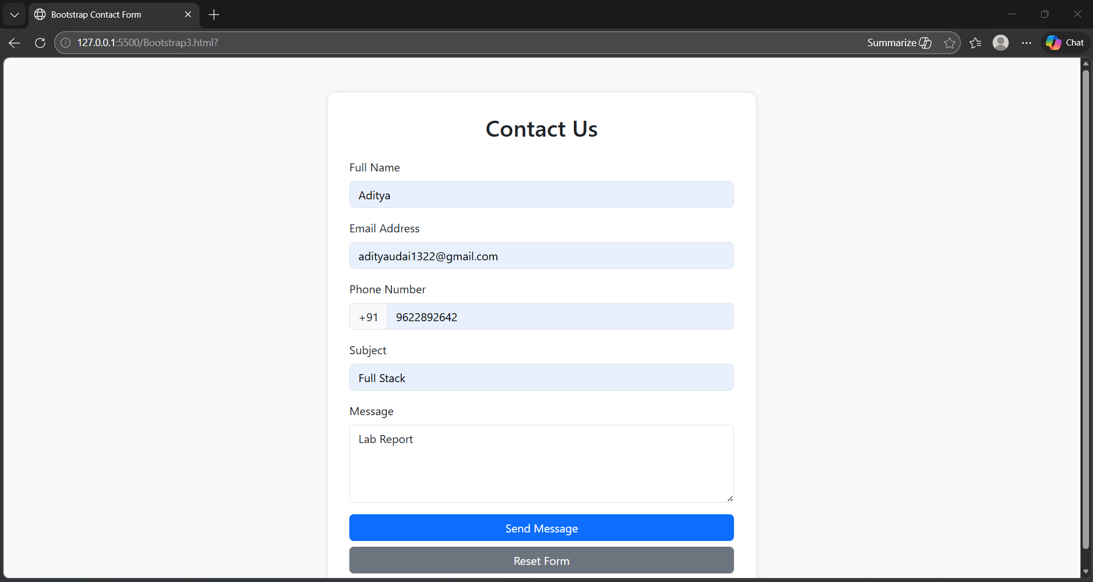
4. Write a program to implement a responsive navigation bar in Bootstrap
that collapses into a hamburger menu on smaller screens using the
collapse component.
HTML Code
<!DOCTYPE html>
<html lang="en">
<head>
<meta charset="UTF-8">
<meta name="viewport" content="width=device-width, initial-scale=1.0">
<title>Responsive Bootstrap Navbar</title>
<link href="https://cdn.jsdelivr.net/npm/bootstrap@5.3.2/dist/css/bootstrap.min.css" rel="stylesheet">
</head>
<body>
<nav class="navbar navbar-expand-lg navbar-dark bg-dark">
<div class="container">

<a class="navbar-brand" href="#">MyWebsite</a>

<button class="navbar-toggler" type="button" data-bs-toggle="collapse" data-bs-target="#navbarMenu">

<span class="navbar-toggler-icon"></span>

</button>

<div class="collapse navbar-collapse" id="navbarMenu">

<ul class="navbar-nav ms-auto">

<li class="nav-item">
<a class="nav-link active" href="#">Home</a>
</li>

<li class="nav-item">
<a class="nav-link" href="#">About</a>
</li>

<li class="nav-item">
<a class="nav-link" href="#">Services</a>
</li>

<li class="nav-item">
<a class="nav-link" href="#">Gallery</a>
</li>

<li class="nav-item">
<a class="nav-link" href="#">Contact</a>
</li>

</ul>
</div>
</div>
</nav>
<div class="container mt-5">

<h2>Responsive Navbar Example</h2>

<p>
Resize the browser window to see the navigation menu collapse into a hamburger menu on smaller screens.
</p>
</div>
<script src="https://cdn.jsdelivr.net/npm/bootstrap@5.3.2/dist/js/bootstrap.bundle.min.js"></script>
</body>
</html>

Output:
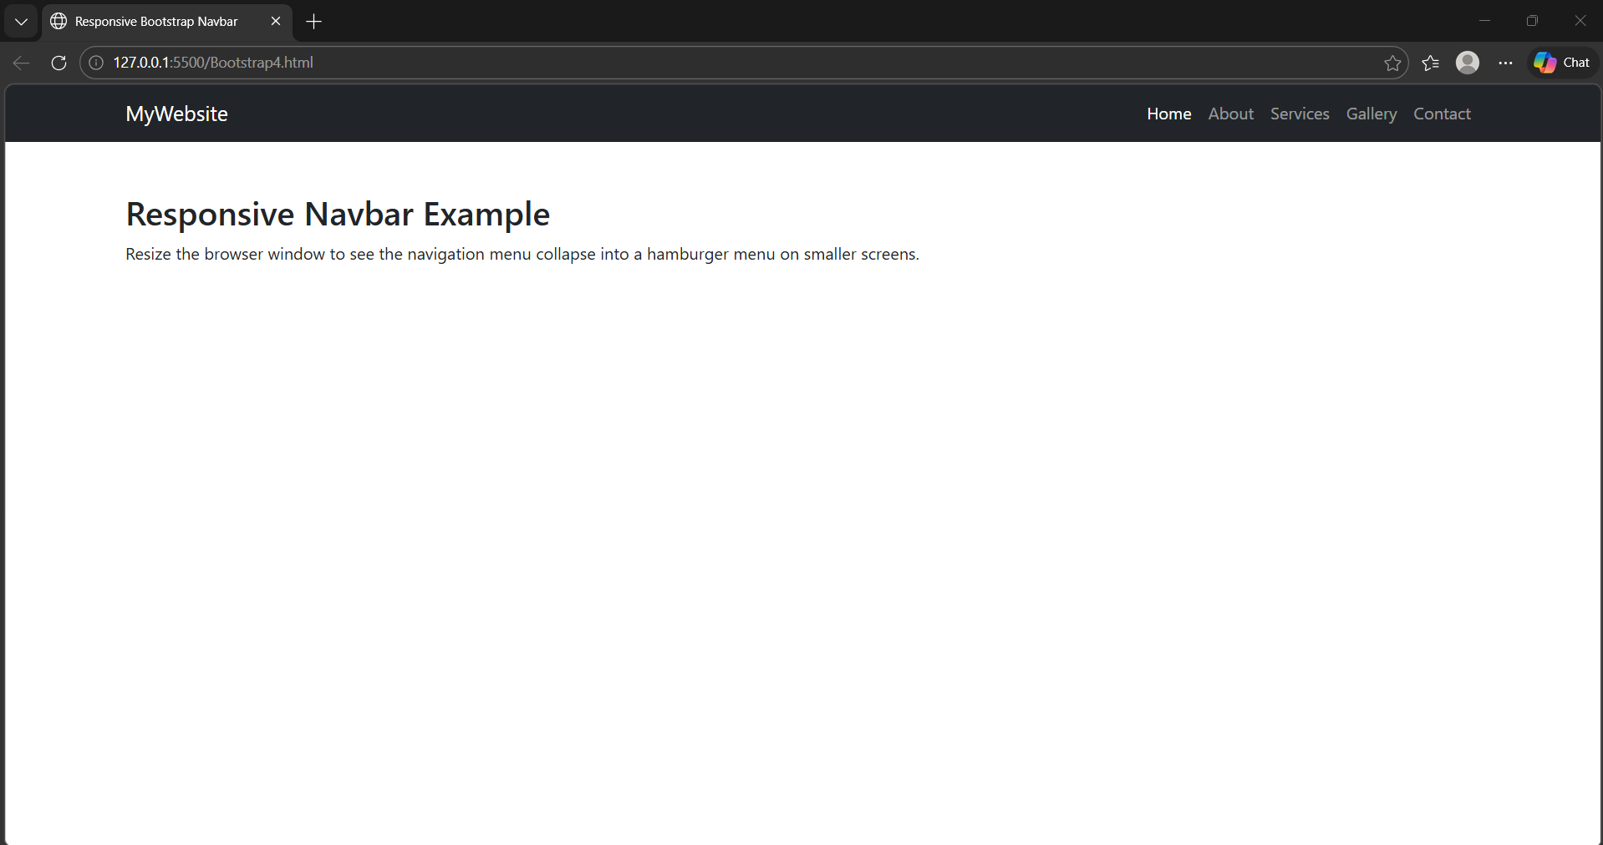
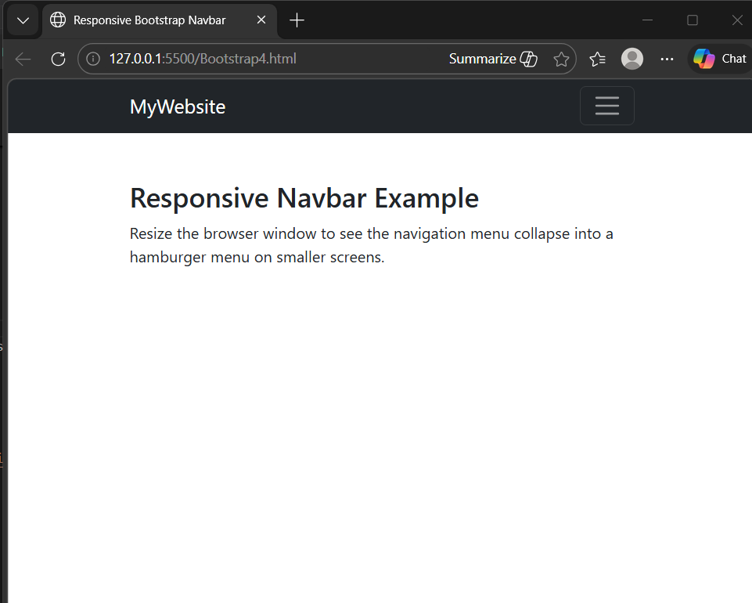

5. Write a program to create a button that opens a modal window containing
a login form. Also, add a tooltip to one of the input fields to give
a hint.
HTML Code:
<!DOCTYPE html>
<html lang="en">
<head>
<meta charset="UTF-8">
<meta name="viewport" content="width=device-width, initial-scale=1.0">

<title>Bootstrap Modal Login Form</title>
<link href="https://cdn.jsdelivr.net/npm/bootstrap@5.3.2/dist/css/bootstrap.min.css" rel="stylesheet">
</head>
<body class="bg-light">

<div class="container text-center mt-5">

<h2 class="mb-4">Bootstrap Modal Login Example</h2>
<button type="button" class="btn btn-primary" data-bs-toggle="modal" data-bs-target="#loginModal">
Open Login Form
</button>

</div>
<div class="modal fade" id="loginModal" tabindex="-1">

<div class="modal-dialog">
<div class="modal-content">
<div class="modal-header">

<h5 class="modal-title">User Login</h5>

<button type="button" class="btn-close" data-bs-dismiss="modal"></button>

</div>
<div class="modal-body">

<form>
<div class="mb-3">

<label class="form-label">Email Address</label>

<input type="email"
class="form-control"
placeholder="Enter your email"
data-bs-toggle="tooltip"
data-bs-placement="right"
title="Enter your registered email address">

</div>
<div class="mb-3">

<label class="form-label">Password</label>

<input type="password"
class="form-control"
placeholder="Enter your password">

</div>
<div class="form-check mb-3">

<input type="checkbox" class="form-check-input">

<label class="form-check-label">Remember Me</label>

</div>

<button type="submit" class="btn btn-success w-100">
Login
</button>
</form>
</div>
<div class="modal-footer">

<button class="btn btn-secondary" data-bs-dismiss="modal">
Close
</button>

</div>

</div>
</div>
</div>
<script src="https://cdn.jsdelivr.net/npm/bootstrap@5.3.2/dist/js/bootstrap.bundle.min.js"></script>

<script>

var tooltipTriggerList = document.querySelectorAll('[data-bs-toggle="tooltip"]')

var tooltipList = [...tooltipTriggerList].map(function (tooltipTriggerEl) {
return new bootstrap.Tooltip(tooltipTriggerEl)
})

</script>

</body>
</html>

Output:
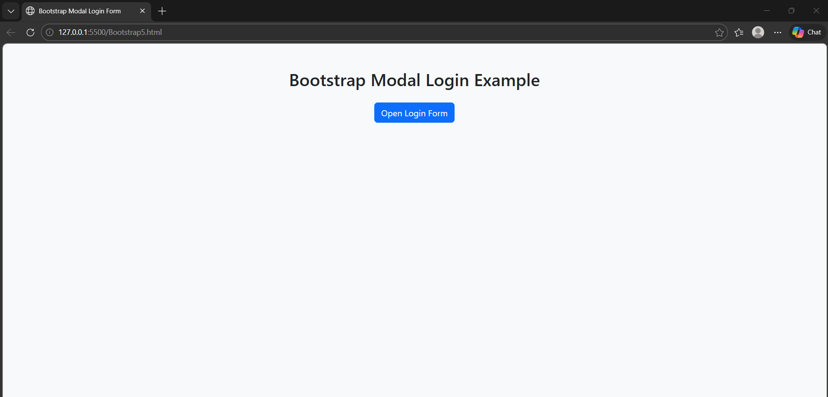
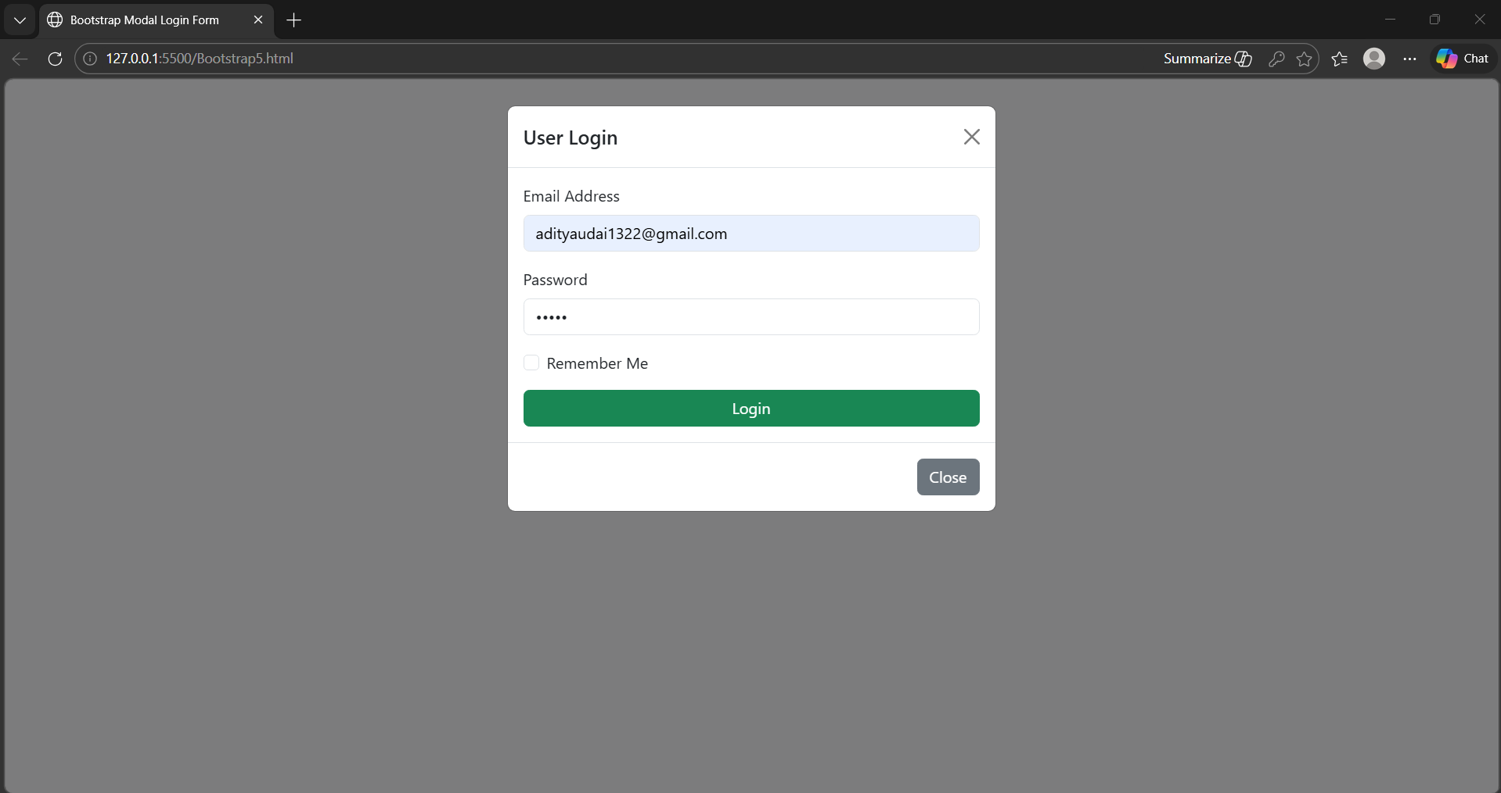
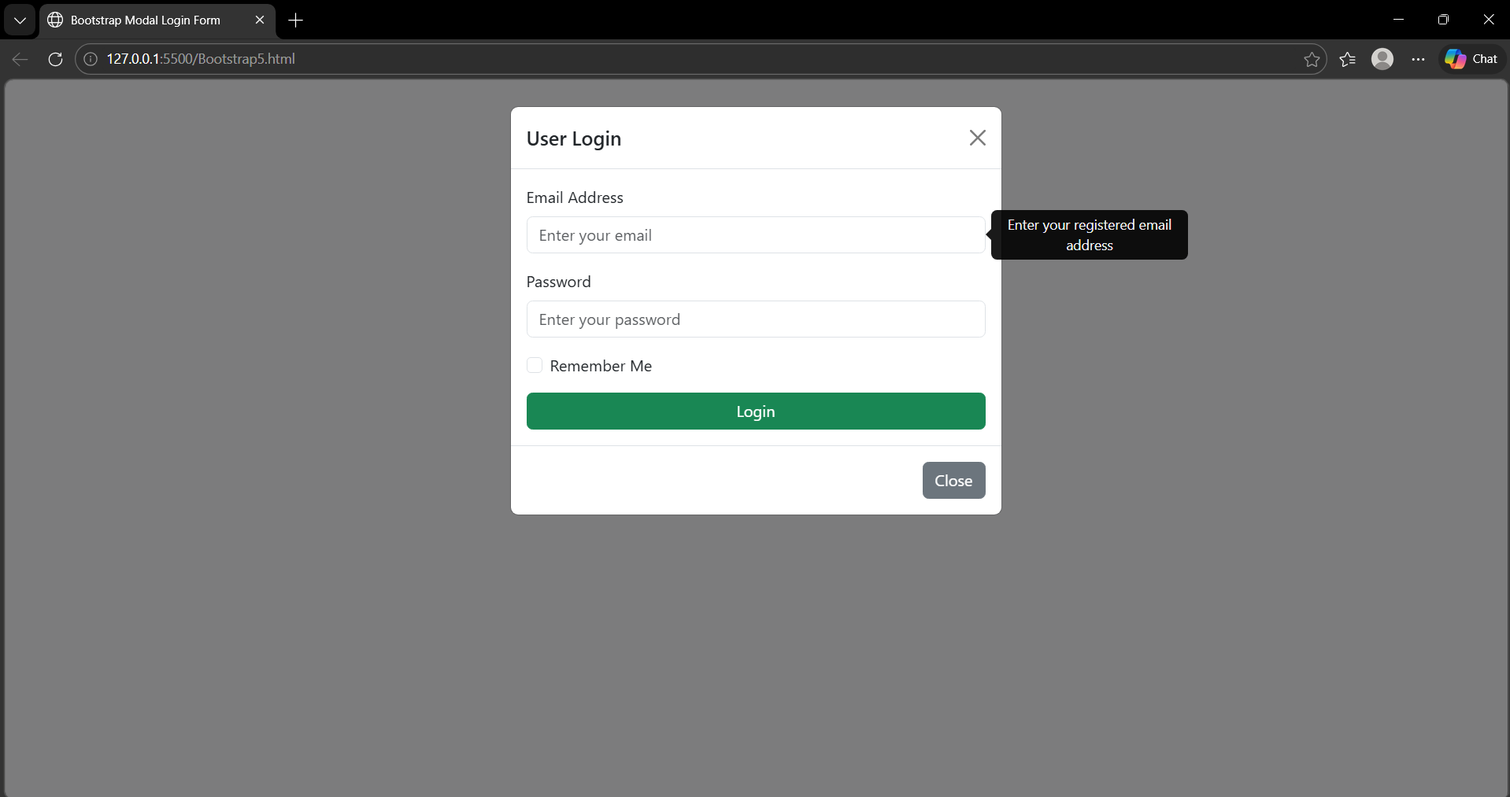
6. Write a program to demonstrate the use of Bootstrap’s utility classes
(for spacing, colors, and text alignment) along with flexbox classes
(d-flex, justify-content, align-items) to build a flexible layout.
HTML Code
<!DOCTYPE html>
<html lang="en">
<head>
<meta charset="UTF-8">
<meta name="viewport" content="width=device-width, initial-scale=1.0">

<title>Bootstrap Utility and Flexbox Example</title>

<link href="https://cdn.jsdelivr.net/npm/bootstrap@5.3.2/dist/css/bootstrap.min.css" rel="stylesheet">

</head>

<body class="bg-light">

<div class="bg-primary text-white text-center p-4">
<h1>Bootstrap Utility & Flexbox Layout</h1>
<p class="mb-0">Demonstrating spacing, colors, alignment and flexbox</p>
</div>

<div class="container my-5">

<h3 class="text-center mb-4">Flexbox Cards Layout</h3>
<div class="d-flex justify-content-between align-items-center flex-wrap gap-3">

<div class="bg-success text-white p-4 text-center" style="width:250px;">
<h5>Box 1</h5>
<p>This box uses spacing and background color utilities.</p>
</div>

<div class="bg-warning text-dark p-4 text-center" style="width:250px;">
<h5>Box 2</h5>
<p>Flexbox aligns items horizontally in the container.</p>
</div>

<div class="bg-info text-white p-4 text-center" style="width:250px;">
<h5>Box 3</h5>
<p>Utility classes help create layouts quickly.</p>
</div>
</div>
</div>
<div class="container">

<h3 class="mb-3">Text Alignment Utilities</h3>

<p class="text-start bg-light p-3 border">
This text is aligned to the left using <b>text-start</b>.
</p>

<p class="text-center bg-light p-3 border">
This text is aligned to the center using <b>text-center</b>.
</p>

<p class="text-end bg-light p-3 border">
This text is aligned to the right using <b>text-end</b>.
</p>

</div>
<div class="bg-dark text-white text-center p-3 mt-5">
<p class="mb-0">© 2026 Bootstrap Flexbox Demo</p>
</div>
<script src="https://cdn.jsdelivr.net/npm/bootstrap@5.3.2/dist/js/bootstrap.bundle.min.js"></script>

</body>
</html>

Output:
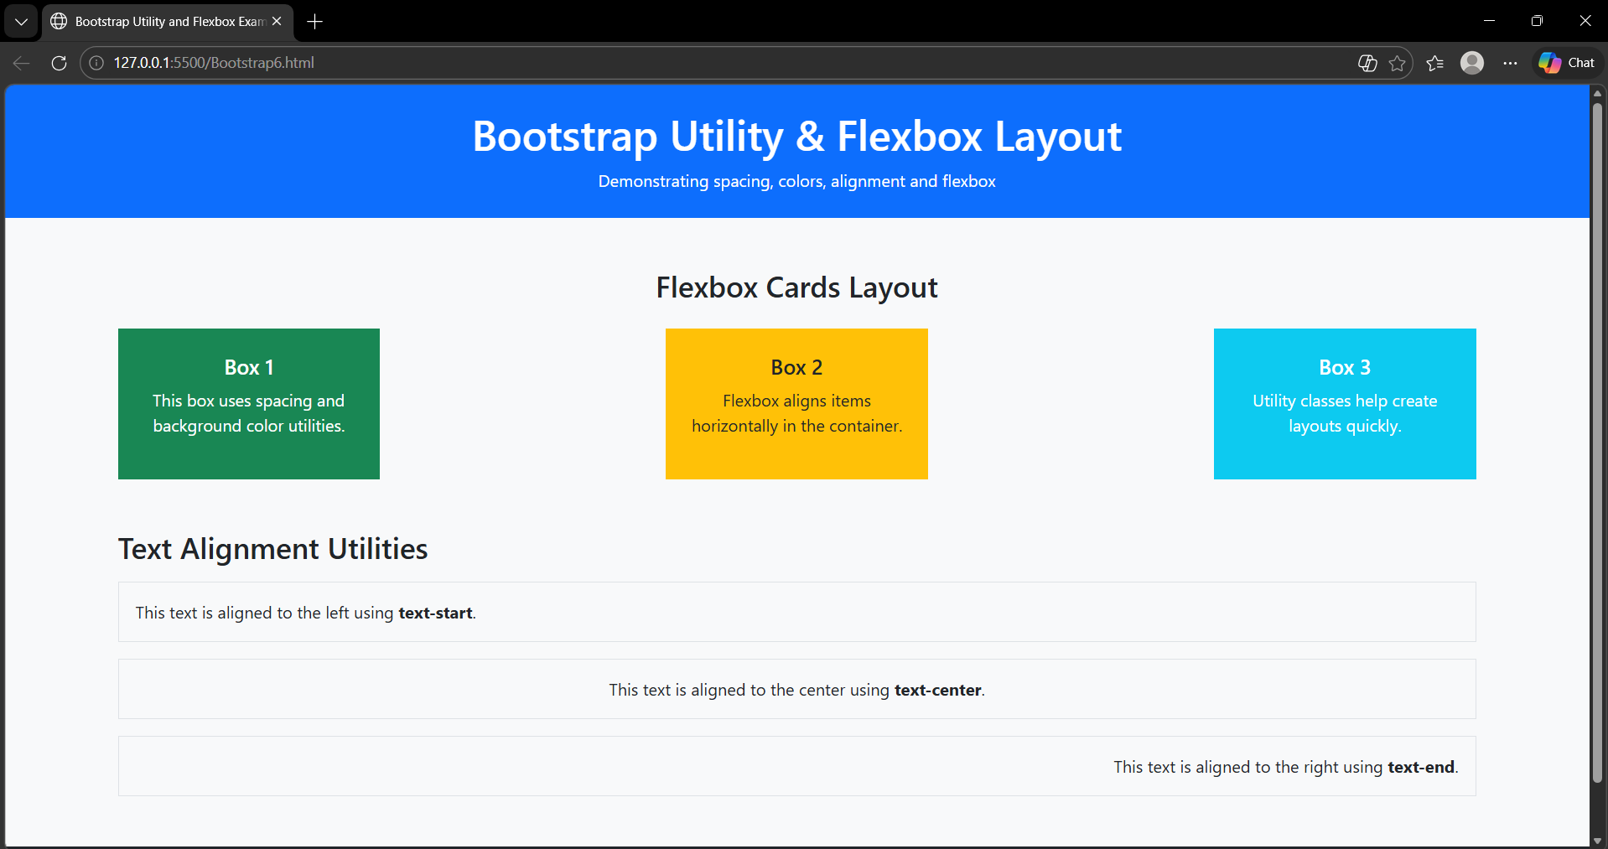
7. Write a program to add an image carousel to a webpage using Bootstrap
and use badges to highlight a featured or new product.
HTML Code
<!DOCTYPE html>
<html lang="en">

<head>
<meta charset="UTF-8">
<meta name="viewport" content="width=device-width, initial-scale=1.0">

<title>Bootstrap Carousel and Badges Example</title>

<link href="https://cdn.jsdelivr.net/npm/bootstrap@5.3.2/dist/css/bootstrap.min.css" rel="stylesheet">

</head>

<body class="bg-light">

<div class="container text-center my-4">
<h1>Car Showcase</h1>
<p>Bootstrap Carousel and Product Badges Example</p>
</div>

<div class="container mb-5">

<div id="carCarousel" class="carousel slide" data-bs-ride="carousel">
<div class="carousel-indicators">
<button type="button" data-bs-target="#carCarousel" data-bs-slide-to="0" class="active"></button>
<button type="button" data-bs-target="#carCarousel" data-bs-slide-to="1"></button>
<button type="button" data-bs-target="#carCarousel" data-bs-slide-to="2"></button>
</div>
<div class="carousel-inner">

<div class="carousel-item active">
<img src="1.jpg" class="d-block w-100" alt="Tesla Model S">
<div class="carousel-caption d-none d-md-block">
<h5>Tesla Model S</h5>
<p>Luxury electric car with advanced technology.</p>
</div>
</div>

<div class="carousel-item">
<img src="2.jpg" class="d-block w-100" alt="BMW M4">
<div class="carousel-caption d-none d-md-block">
<h5>BMW M4</h5>
<p>High performance sports coupe.</p>
</div>
</div>

<div class="carousel-item">
<img src="3.jpg" class="d-block w-100" alt="Audi R8">
<div class="carousel-caption d-none d-md-block">
<h5>Audi R8</h5>
<p>Supercar with incredible power and design.</p>
</div>
</div>

</div>
<button class="carousel-control-prev" type="button" data-bs-target="#carCarousel" data-bs-slide="prev">
<span class="carousel-control-prev-icon"></span>
</button>

<button class="carousel-control-next" type="button" data-bs-target="#carCarousel" data-bs-slide="next">
<span class="carousel-control-next-icon"></span>
</button>

</div>

</div>
<div class="container">

<h2 class="text-center mb-4">Featured Cars</h2>

<div class="row g-4">

<div class="col-md-4">
<div class="card">

<img src="4.jpg" class="card-img-top">

<div class="card-body">

<h5 class="card-title">
Lamborghini Huracan
<span class="badge bg-danger">Featured</span>
</h5>

<p class="card-text">
A powerful Italian supercar known for its stunning design and extreme speed.
</p>

<a href="#" class="btn btn-primary">View Details</a>

</div>
</div>
</div>
<div class="col-md-4">
<div class="card">

<img src="5.jpg" class="card-img-top">

<div class="card-body">

<h5 class="card-title">
Porsche 911
<span class="badge bg-success">New</span>
</h5>

<p class="card-text">
Legendary sports car with precision engineering and exceptional handling.
</p>

<a href="#" class="btn btn-primary">View Details</a>

</div>
</div>
</div>
<div class="col-md-4">
<div class="card">

<img src="6.jpg" class="card-img-top">

<div class="card-body">

<h5 class="card-title">
Mercedes AMG
<span class="badge bg-warning text-dark">Hot</span>
</h5>

<p class="card-text">
Luxury performance vehicle combining comfort and powerful engineering.
</p>

<a href="#" class="btn btn-primary">View Details</a>

</div>
</div>
</div>
</div>
</div>
<div class="bg-dark text-white text-center p-3 mt-5">
<p class="mb-0">© 2026 Car Showcase | Bootstrap Demo</p>
</div>
<script src="https://cdn.jsdelivr.net/npm/bootstrap@5.3.2/dist/js/bootstrap.bundle.min.js"></script>

</body>
</html>

Output:
